Version 1 September 2025
CUMBRIA REFEREES’ SOCIETY DISCIPLINE POLICY DOCUMENT
Cumbria Referees Society Lead (SDO) brian.mitchelhill@sky.com
Relevant RFU Regulation
https://www.englandrugby.com/run/rules-governance/rfu-rules-and-regulations/regulation-19-discipline

Red Card Dismissal

- Once explained to the player and their Captain you should not engage in further discussion.
- The players Club will be aware of the process and their duty to report the dismissal.

All Red Card Dismissals must be reported by Referee & Club

- If you issue a Red Card, you must register this via text or What’s App to SDO Brian Mitchelhill 07800 613 122 and Mike Firby 07831 245 888 after the match. If SDO is unavailable, Secretary Alan Jenkinson 07983687370 will then contact you to discuss the circumstances.
- You are then required to complete the appropriate form by close of play the following day. This can be found at www.whostheref.com It must be completed online.
a. The Age Grade Version is not available but can be found www.englandrugby.com It should be completed and emailed to SDO. ( or if SDO unavailable the secretary.)
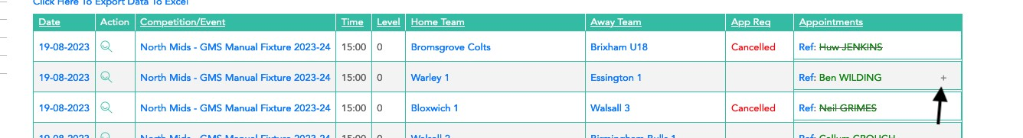
Go on WTR – then fixtures -then they click on the “+" the MOA Form will appear
, a second click brings up the Red Card Form

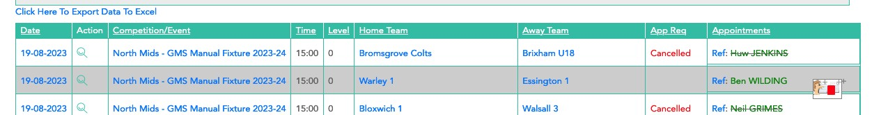
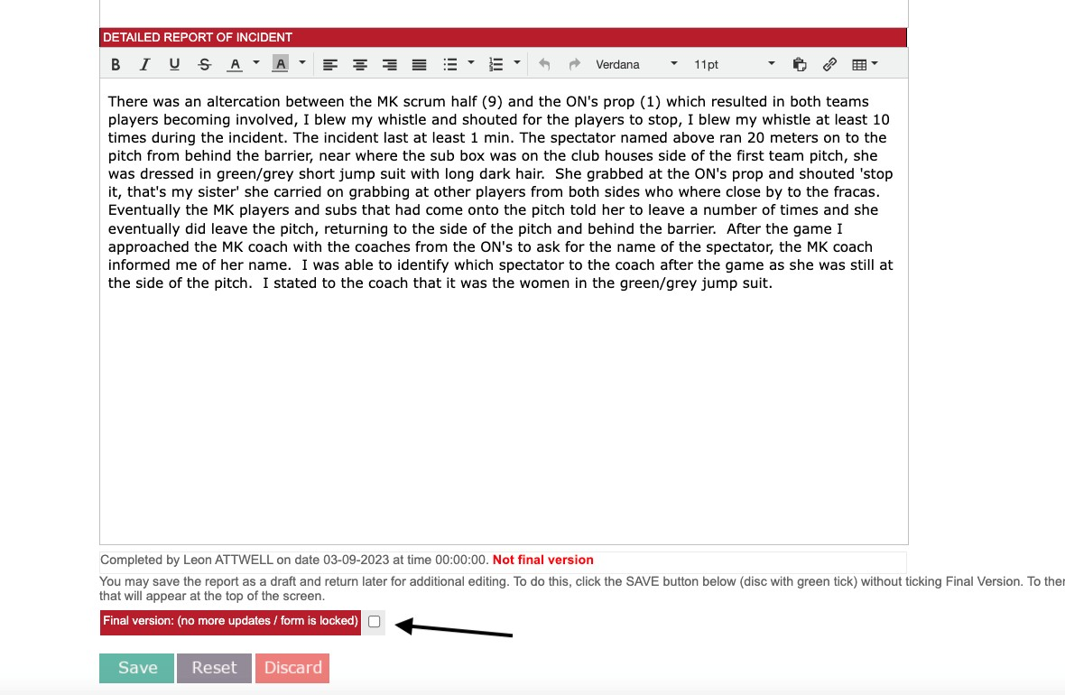

DO NOT TICK THIS BOX UNTIL THE SOCIETY SDO HAS APPROVED YOUR FORM.

By clicking SAVE only, a draft version will be saved visible to the Society Disciplinary Officer
(SDO) who will let you know when to save the final version.

2 All referee disciplinary reports are now moderated by the SDO. After completing your draft, you should NOT finalise the report until you have reviewed his comments.
3.The SDO will now phone you to discuss your report, maybe to suggest amendments or the Report
is ok to finalise and send. - Do not finalise the report until you are requested to by the SDO
4.To finalise the report (within 48hrs of conclusion of match) Open WTR site

Guidance

Be concise | Elaborate
Be factual (I saw…) | It was retaliation from something I did not see
Be as specific as you can (… A strike B forcibly on the head with their hand) | Words like “punch,” “stamp” …. Unless you are sure
The effect of the foul play. “…drew blood, …. treatment needed…” | Your opinion

- Match Official Abuse Form (MOAF)
  - This must only be issued to spectators!
  - For a player, substitute or member of the playing support staff (those inside the barrier) ONLY a Red Card report is required.
  - The above applies until the referee leave the club a reasonable time after the match.
  - To make the case referees are strongly advised that when they become aware of spectator abuse from the sideline, they STOP the match, call over the team Captain, alert them to your concern and ask them to address it. This logs this on any video.
- The MOAF will be considered by the disciplinary panel, so it is important to document how the abuse made you feel.
  - Such is the importance of this report you must liaise with SDO when drafting.

Guidance

Attribute comments… “spectator 1 said” | “There were shouts from spectators”
What was said, “you are an ****” | They said I was useless
Who it was to “…….…. Looked directly into my eyes and said….” | Shouted from the side of the pitch.
How it made you feel… “I felt threaten and unsafe” | I’ve been around years, and I have heard worse”
“I reported this to the captain at the time.”  “The Blue 14 heard the comments”. “I wrote down the words used at the time” | “I got home and thought I needed to do something.”  “They said something like….”  “The player shouted and made various comments criticising my refereeing”

Yellow Card - Caution

- These are not reportable but match official abuse should be registered with the SDO

- Guidance
 | 
Second Yellow Card | Dissent
Physical abuse | Repeated questioning of decisions
Foul and abusive language | Remonstrated, Contested decision
Invasion of personal space | Refuses to listen and/or walks away
Threatening words or behaviour | Talks about you

- Use of Discriminatory Language
As you all know, central to our game are the core values that we hold close; Rugby's values of Teamwork, Respect, Enjoyment, Discipline and Sportsmanship are what makes the game special for those who enjoy the environment and culture they create. They define the game and define England Rugby. It is of paramount importance that the ethos of the game is maintained by instructing young people coming into the game the values which have made the sport unique and a sport for all.
Often, during games we will either become aware of discriminatory language, either because it is reported to us or it is heard directly, amongst players or from spectators or those in technical areas. Although might not be directed at us as Match Officials, it must be reported in an appropriate fashion. All reports of this nature are to be directed to RFU Discipline
If you have directly heard and witness, discriminatory language, which includes references to race, religion, disability, gender, or sexual orientation, this could warrant a red card.
However, there might be instances, for example where you have not witnessed or directly heard the comments whereby you feel it is not a place for you to issue a red card; when this the case, please recorded the details of the offender, witnesses, what was said and to whom. Please contact the SDO who may advise you to email the RFU Speak Up line speakup@rfu.com Do not do this until contacting the SDO.
In instances where you have not heard or witnessed the discriminatory language, but players have reported this to you it is important to record that fact as part of the reported information and report this to the SDO as soon as practical.
You are not expected to be investigating this on the day or afterwards. It is not for you to prove the events, but it is incumbent on you to report events that are directly heard or reported to you; it is vital that the SDO is aware of the incident so appropriate investigations, and potentially action, can take place.

Guidance

The information that might be useful to record at the earliest convenience and could be forwarded to the Speak up (SpeakUp@rfu.com) line, after speaking to the SDO include:
- The match, date, time, and it’s location.
- The time the alleged or witness incidents.
- Anyone you suspect is involved, as the reporting party, a witness, victim, or possible perpetrator/s.
- What is alleged to or what happened. I.e., 12 Red has alleged that 13 Blue has used a racial slur against him, the slur that was discussed with me was x.

Whilst you could ask for the individuals names if it is not a player involved, it is advisable to consider your safety first and not to place you at any unnecessary risk. Ultimately, you are just report the facts as you have been told or witnessed to the RFU for follow-up investigation.
The Constituent Body Disciplinary Process
- Having issued a Red Card or submitted a Match Official Abuse Form the disciplinary process is completed by the player’s Club’s Constituent Body Disciplinary Committee (CBDC). Their findings are not a reflection on the referees’ decision or performance. Reports and their decisions are monitored by our SDO. Other than repeating your on-field decision you should not discuss your decision with anyone other than the SDO in the first instance.
- Both the Cumbria Discipline and the Society are governed by the procedures and sanctions within RFU Regulation 19, and the RFU procedures pertaining to this.
Red Card Hearings (Adult)
- The Constituent Body (CB) of the player’s Club will require the Club to conduct an internal Disciplinary Hearing.
- Thereafter the person may be called to appear before the CBDS.
- If they plead not guilty and/or wish to challenge the contents of the referee’s report the referee must be invited to participate at the hearing.
- Discipline will contact the referee if so invited. Referee please inform the SDO
- There are several options for the referee: -
      - They participate in the hearing; A Society official is available to go along BUT they are not allowed to contribute to the proceeding.
      - They participate via a telephone or video link.
      - They review the Club Judgement Form, and any evidence made available to them and make a written statement for consideration.

Notes
  - The referee’s evidence is treated as independent by the CBDC.
  - The referee does not have to participate in person.
  - The player can only challenge the referee if they request their participation. Otherwise, they will be deemed to have accepted the Referee’s report.
  - The process is such that they may be invited at very short notice.
  - If the referee wishes to know the outcome, they should contact the DL.
Red Card Hearings (U18)
- As above except the player will NOT be asked to attend a CBDC hearing.
Match Official Abuse Hearing (Adult & U18)
As above but additionally
- RFU Regulation 19 allows you to provide an impact statement. Referees are urged to do so.
- Referees are urged to note the details of any witnesses to the abuse.
- The CBDC are aware that “RFRU/ Ref Society may offer to present any case” which the Society are willing to do for you should the CBDC allow this.

Quick Guide on dismissing a player, substitute, or member of the playing staff. Red Card

During the Match:

- Whistle to stop play.
- Move away from the incident and find space. If you are followed; hands up with open palms and move further away.
- TAKE TIME TO THINK
- Call over the Team Captain, get the player’s name and then issue the card. You do not need to engage with the player.
  - If the Captain is the culprit use another player.
  - If the Captain speaks whilst you are – STOP and wait for them to be quiet.
  - In extremis politely disengage with the team Captain and call over a compliant player.

DO NOT OFFER ANY VIEW POST MATCH.

REFER ALL TO YOUR REPORT WHICH THEY WILL RECEIVE FROM THE CBDC

Within 48 hours of the Match:

24 You may have a check list to record the information you need, so make notes.

YOU MUST COMPLETE A DISCIPLINARY REPORT

- Register the dismissal via 07800 613 122 Brian Mitchelhill -The Society Disciplinary Lead (SDO) and also text Mike Firby (Chair) 07831 245 888
- If you require any help from the SDO who will if requested either speak to you or email you notes to support your report writing.
- Complete a DRAFT report on www.whostheref.com

DO NOT FINALISE THE REPORT

- The Society Disciplinary Officer will then contact you.

DO NOT FINALISE THE REPORT UNTIL YOU ARE REQUESTED TO.

It is expected that all Report Writing and Submission procedures are completed within 48 hours of the conclusion of the match.

The Quick Guide on dismissing a spectator & MOA.

During the Match

- Wait until a break in play, or in extremis whistle to stop play.
- TAKE TIME TO THINK. You will need to identify the person. It is good practice to make a note of any distinguishing features.
- Call over the Team Captain, & Coach from the sideline and point out the person to them.
- Explain that the person must return to the Clubhouse before the match can continue. Explain you will need their name for your report AFTER the match.

DO NOT OFFER ANY VIEW POST MATCH. REFER ALL TO YOUR REPORT WHICH THEY WILL RECEIVE FROM THE CBDC

- After the match you should engage with the Team Captain & Coach to obtain the name of the spectator.

- If they cannot or will not identify the spectator, note this.

- Within 48 hours of the Match:

YOU MUST COMPLETE AN MOAF ON WTR.

- Register the incident via 07800 613 122 The Society Disciplinary Officer (SDO) who if requested will support your report writing.

- Complete a DRAFT report on www.whostheref.com

DO NOT FINALISE THE REPORT - The Society Disciplinary Officer will then contact you.

DO NOT FINALISE THE REPORT UNTIL YOU ARE REQUESTED TO.

